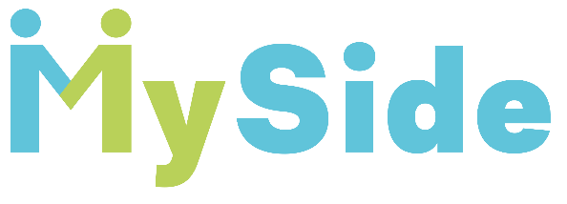
Job Description
Teaching Assistant:
Equine and small animals.

REPORTS TO: Lead Teacher

KEY PURPOSE OF THE JOB:
To support a small group of young people (3/4) to access core education every day.
To offer a diverse and engaging daily program based around Equine and small animals.
All the students at MySide are aged 9-14 years and unable to presently access mainstream education and have Education, Health Care Plans for varying disabilities that inhibit processing needs.

Outcomes of role:

- Develop and deliver a wide ranging and engaging sessions
- With support deliver the content and pedagogy with Therapist and other SEND experts.
- Map and track individual progress and outcomes for each learner with the staff team.
- Ensure the safety and wellbeing of Students attending MySide provision in line with all statutory requirements and MySide’s Policies and Procedures.

PERSONAL ATTRIBUTES
- To have high expectations of young people with SEN including a commitment to ensuring that they can achieve their full educational potential.
- Be creative, adaptable and self-motivated, - They should have great energy and rapport with young people, being warm and caring, as well as maintaining firm boundaries for safety and wellbeing.
- Manage time and prioritise effectively to ensure outcomes and delivery of projects in given timeframes.
- To evaluate their performance and be committed to improving their practice through appropriate professional development.
- To be able to work well with a team and communicate effectively with each other
- To be able communicate effectively with professionals, young people and families.
- To be respectful, welcoming and supportive towards stakeholders
- To adapt practice where benefits and improvements are identified.
- To act upon advice and feedback and be open to coaching and mentoring.
- Actively demonstrate our values within all contexts.

Values
- We are ambitious for young people with SEND
- We foster independence in each unique young person
- Equal opportunities for every young person to access appropriate educational provision to reach their true potential
- Foster a culture of growth and learning in order to understand, embrace and value the diversity of those who simply think or develop differently
- For every workplace to broaden their definition of Neurodiversity and for this to become the norm

We are committed to these four core values
- Ambitious Futures
- Equal Opportunities
- Empowerment
- Ordinary Neurodiversity

PROFESSIONAL KNOWLEDGE AND UNDERSTANDING
- Previously delivered pedagogy around development needs of learners with Special Educational Needs and Disabilities
- A good understanding and knowledge across the breadth of Special Educational Needs and Disabilities, Neurodiversity, including young people presenting on the edge of the autistic spectrum including PDA traits, as well as with many young people affected by acute medical conditions.
- Up to date knowledge around Equine, small animals, Health and Safety associated to best practice and regulations.

PROFESSIONAL SKILLS

- Very good communication and presentation skills.
- Well-developed IT Skills include Microsoft packages.
- Minimum SEN Level 2 qualification or equivalent or a willingness to complete prior to start date.
- Safeguarding qualifications at least Level 2 or willingness to complete prior to start date.

